12 Way Vertically Mounted Surge Protected Rackmount PDU - UK Sockets (PDU-12WS-V-SP-1U)

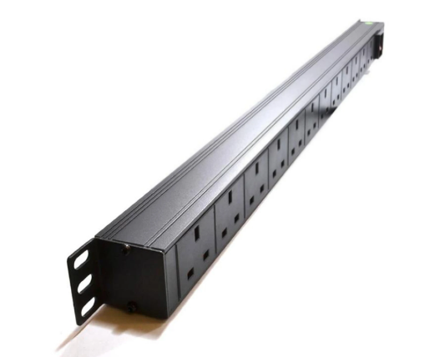

Description:
The LMS Power PDU-12WS-V-SP-1U is a high-quality surge protected, vertically mounted PDU (Power Distribution Unit) that simply fits within the universal mounting brackets of data, telecom and server cabinets.
Providing piece-of-mind of integral electrical surge protection against common power surges and electrical spikes to devices including Ethernet Switches, Servers, UPS, NAS and of course cabinet accessories including cooling fan trays.
Robust, alloy design complete with rackmount brackets fitted, high-quality Neon Switch and of course UK output sockets together with a high quality, BSI-fitted
13 Amp UK plug.

Key Features:

Standard UK 3-Pin power outlets for your appliances

Built-in surge protection for critical device protection

1U vertically mounted attaches to internal profiles

Neon On/Off Rocker switch to prevent accidental turn off

Backed up by LMS Power's exclusive 3-year warranty

Applications:
Create instant power feeds to your data, telecom or server cabinets
Provide effective power for cabinet cooling fans, UPS systems
Ideal as stand-alone trailing sockets outside the cabinet

Product Code:
Part Number: PDU-12WS-V-SP-1U
EAN: 8400800021038
Weight: 1.6Kg approx

Technical Specifications:
Warranty LMS Data 3-Year Warranty
Chassis 1U vertical PDU with mounting brackets
Output Sockets 12 UK 3-PIN Sockets
Power Input Fitted UK 3PIN BSI Plug 13 Amp
Flex Length 1.8 metres (approx)
Power Control On/Off Rocker Switch (illuminated)
Power Rating 4000 Watts (approx) Surge Protected

Supplied With:
PDU-12WS-V-SP-1U 12 Way Vertical PDU
Cabinet brackets (Fitted)
* Specifications and product design are subject to change. E&OE.

Are you looking to protect your valuable Networking, IT or Telco infrastructure from damaging voltage surges? Need a low cost but effective solution for wide scale deployment that prohibits the usage of full scale UPS systems? The new LMS Data SurgePro range of Voltage Surge protected Power Distribution Units (PDU) allow just that sort of protection for your equipment. Featuring the latest in Metal Oxide Varistor (MOV) technology, the SurgePro will block any input voltage surges up to around 4 times the nominal input voltage, meaning your IT Networking Switches, Servers, NAS devices and PBX device s will run for longer and thus reduce system downtime.

specifications:
Voltage Surge Protected Power Distribution
MOV (metal oxide varistor) Surge technology
TSD (transient suppression diode) Spike prevention
Surge system LED confirmation
Standard vertical design for Enclosure fitment
Standard UK type sockets; rated 13A; 12 Way
Protected neon On/Off Switch
Generous 1.8 approx. metre high-load UK cable

